**PRACTICAL-4-SUBMISSION SAMPLE PDF FILE**

1. **Draw dependency diagram and identify all dependencies (REGULAR, PARTIAL and TRANSITIVE)**  **(1 MARK)**

**Optional diagram below**

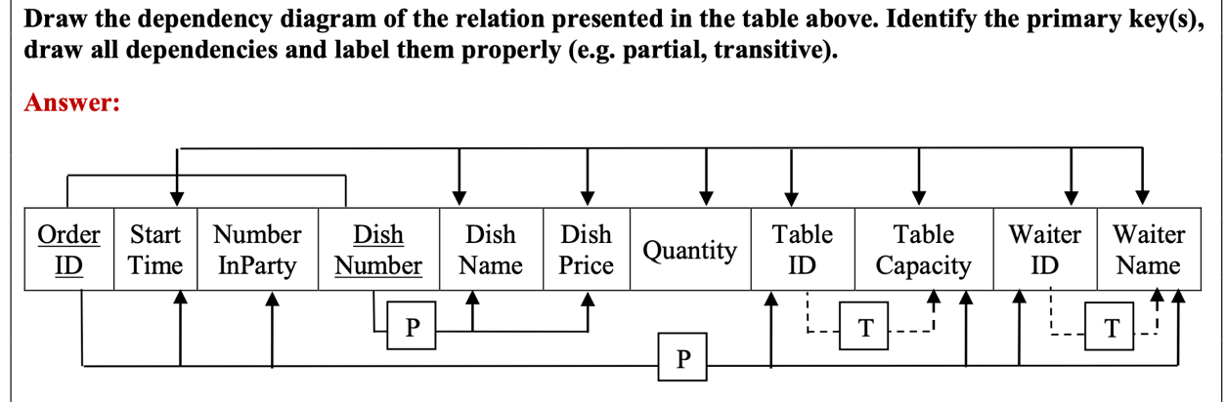

**MANDATORY textual representation below**

**1NF**

* **Regular Dependency:**

(OrderID, DishNumber) 🡪 (StartTime, NumberInParty, DishName, DishPrice, Quantity, TableID, TableCapacity, WaiterID, WaiterName)

* **Partial Dependency:**

OrderID 🡪 (StartTime, NumberInParty, TableID, Table Capacity, WaiterID, Waiter Name)

DishNumber 🡪 (DishName, DishPrice)

* OR – State that no partial dependencies are found.
* **Transitive Dependency:**  
  TableID 🡪 TableCapacity

WaiterID 🡪 WaiterName

* OR – State that no transitive dependencies are found.

1. **Final 3NF Format**. **(1 MARK)**

**Show steps of normalisation** :

**2NF**

* ORDER (**OrderID**, StartTime, NumberInParty, TableID, Table Capacity, WaiterID, Waiter Name) – not 3NF
* MENU (**DishNumber**, DishName, DishPrice) – already in 3NF
* ORDER-LINE (**OrderID, DishNumber,** Quantity) -already in 3NF

**3NF**

* TABLE (**TableID**, TableCapacity)
* WAITER (**WaiterID**, WaiterName)
* ORDER (**OrderID**, StartTime, NumberInParty, TableID, WaiterID) – 3NF

**FINAL SET OF NORMALISED TABLES**

* ORDER-LINE (**OrderID, DishNumber,** Quantity)
* MENU (**DishNumber**, DishName, DishPrice)
* ORDER (**OrderID**, StartTime, NumberInParty, TableID, WaiterID)
* TABLE (**TableID**, TableCapacity)
* WAITER (**WaiterID,** WaiterName)

1. **Draw the Crow’s Foot ERD. Submit *.MWB and *.PNG (Export as PNG File)** **(1 MARK)**

**-END-**